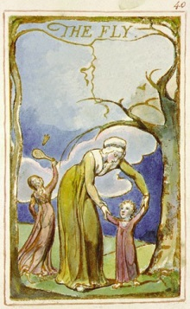
sitting by the pool acting so cool
Wearing all my bling and jewels
A fly came across and laid in my head
With its big evil eyes so red

It buzzed around and around
I can’t handle the buzzing sound
I went inside to hide from the big fly
Yet there it was buzzing inside

I want to kill it with my hands
But I’m willing to give a second chance
To fly way up high in the sky
But it chose to lay on my thigh

Please fly away back to your world
My dream is for it to depart
The big ugly fly smells so bad
I hate you fly, you make me sad

At last I caught you with all my power
I smell stinky, now I’ll take a shower
I hate you stinky little flies
Those brown things taught me to be wise

